

Department of Paediatric Haematology
Bristol Royal Hospital for Children
Upper Maudlin Street
Bristol
BS2 8BJ

Sickle Cell Disease

An Information Pack and Care plan for Parents, Teachers and Carers of

--------------------------------------------
The aim of this pack is to raise awareness of the condition and to provide relevant information on how to support children and young people within school and home settings.
What is Sickle Cell Disease? – Sickle Cell is an inherited blood condition that causes red blood cells to become sickle shaped. This causes pain from lack of oxygen as the red blood cells are unable to travel through the blood vessels effectively. There are two types of Sickle Cell; HbSS and HbSC. It is considered that HbSS is a more serious type of the condition.

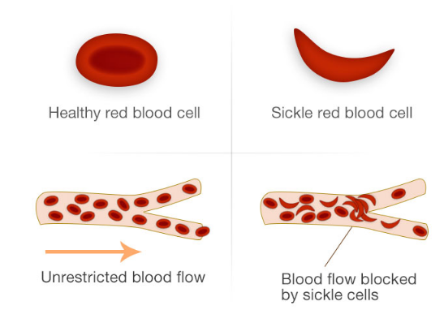
What is Sickle Cell Trait? – Sickle Cell Trait (or carrier) is when a person inherits one unusual S gene and one usual A gene from their parents. A person that has trait will not usually have any symptoms but can pass the gene to their children.
Individuals with Sickle Cell are prone to serious complications from infections and are prescribed daily penicillin to prevent infections. They are usually also required to take daily vitamin D to support strong bones and relieve fatigue along with folic acid which promotes healthy red blood cells.
Sickle Cell can cause severe bouts of pain which is called a “crisis”. Sometimes these can be managed at home using over the counter pain relief. At times hospital admittance is needed for stronger pain relief. Pain can be anywhere in the body, a crisis can cause organ complications if not treated appropriately or promptly. A crisis can be anywhere in the body including the penis. This is called ‘Priapism’ and is a non-sexual erection which requires prompt treatment to avoid any damage to the functioning of the penis.

If complains of pain in abdomen, chest and limbs they may be experiencing a crisis. The following actions are recommended:
Give painkillers if available


Provide fluids


Ensure the child is kept warm


Contact the child’s Parents/Carers


If the child is having breathing difficulties call 999


Child’s Name:  D.O.B:  Address:  Parents/Carers names:  Class and teacher:  Emergency Contact Details:  Alternative Emergency Contact: | Photo of Child:  Condition: Sickle Cell Disease  Date Written:  Review Date:  GP:
Precautions:

- Pupil must be kept warm during the winter and be allowed to wear extra layers and be away from draughts
- The pupil needs to reduce exposure to extreme temperatures – hot or cold
- Unlimited access to water, dehydration can lead to a sickle crisis. This is especially important during hot weather and when playing sport
- Unlimited access to the toilet – a toilet pass would be beneficial
- When swimming the pupil needs to dry themselves quickly once exiting the pool. With discussion from the pool facilitators the pool temperature should be increased if possible
- If the pupil gets wet during PE they should dry and change clothes ASAP

What to do in an emergency:  - Call parents/carers  - Administer pain relief if required | Things to look out for:  - Pain – administer pain relief if required and as prescribed on packaging. Following school protocol.  - The pupil may at times be lethargic
Medication to be administered:  What is the medication for:  Dose:  Route of administration:  Name of person administering:  Print name:  Signature:  Date:  Time: | Medication to be administered:  What is the medication for:  Dose:  Route of administration:  Name of person administering:  Print name:  Signature:  Date:  Time:
Any other information:

https://www.sicklecellsociety.org/

Contact Details of other professionals:  Clinical Nurse Specialists:  Bristol Children’s Hospital  Upper Maudlin Street  Bristol  BS2 8BJ  A&E – 0117 3428344  Benign Haematology Clinical Nurse Specialists 01173428721, 07747004996  07920545620  Benign Haematology Family Support Worker  Hayley Wiles – 01173420658 Mon-Fri 8:30 – 4:30 | Parents Signature:  Signature of person responsible for health conditions in school:

Specific Needs of Children with Sickle Cell
Extra Fluids - A child with Sickle Cell will need to have access to fluids throughout the day. Dehydration could lead to a crisis as the blood becomes thicker and more “sticky”.


Toileting – Due to the extra fluids children need to drink they made need to use the toilet more often. In secondary schools if often helps for the child to have a toilet pass.

Days off school – Sickle Cell can be very unpredictable, the child or young person may be absent from school if suffering a crisis. They will also be absent if attending hospital reviews. They may need additional assistance and may need to have school work provided to prevent them falling behind.


Fatigue – Some children may feel tired, flexible school time tables during this period of time could be an option.


Cold/Draughts/extreme temperatures – Cold weather, a change in temperature or very hot weather can sometimes cause a crisis. It is important that the child keeps warm in the winter and cool in the summer. They should be kept away from draughts and allowed to wear extra layers in school. They may need to be kept indoors during very hot or very cold weather.

Physical Activities and Outdoor Activities

Playtime – As above, children need to be kept warm and dry. Sports and play outside during cold weather and rain should be avoided. If the child does get wet they need to dry and change their clothes ASAP.

Swimming – Children with Sickle Cell should only swim in warm water. Some leisure centres will alter the temperature of the water if they know a particular school is visiting. Once the child exits the pool they should dry and change ASAP.

Physical Activity – Exercise should be encouraged but children and young people should be allowed to find their own limits and recognise their own capacity to participate. They may be reluctant to participate due to pain or lethargy.

Summary

Living with a chronic life-long condition can be emotionally, mentally and physically exhausting. We offer psychology input along with Physio, Clinical Nurse Specialists, Consultants and Support Worker who can all offer support.
Children with Sickle Cell should be encouraged to live as normal life as possible with the support of the wider team and family working together to ensure the child reaches their full potential.
We are available on the above contact numbers for further support or training if required.

Any Other Information

